2022 Belleville Don Gerry Open

Field Designations

Mary Anne Sills Park
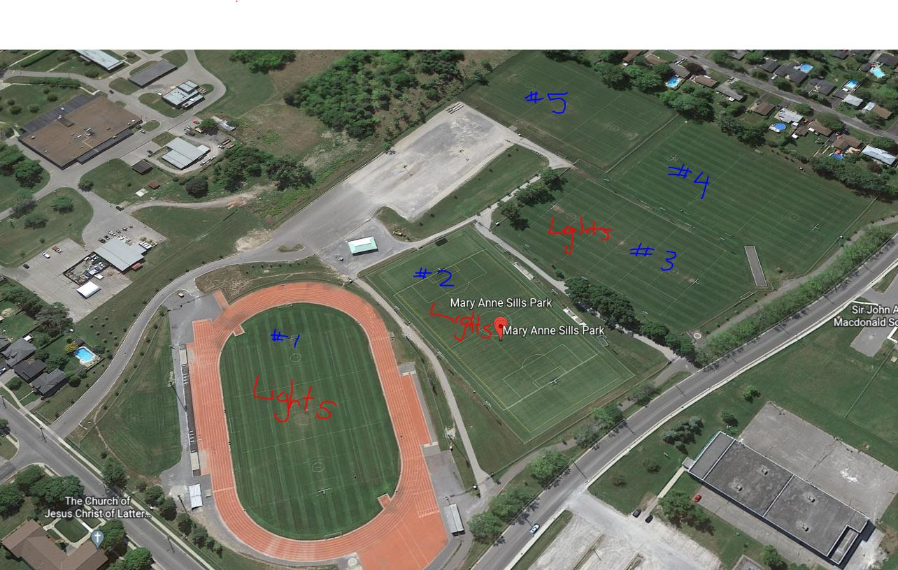
Field A – MAS#2
Field B – MAS#3
Field C – MAS#4
Filed D – MAS#1
Filed E – MAS#5

